**Project Title:** Workforce Administration Solution (Dev)

**College Name:** Adhiparasakthi Engineering College- 4204

|  |  |
| --- | --- |
| **NAME** | **NM ID** |
| Mathiyarasi P(Team Leader) | 4E97B4FCF004E31A20F4134844168871 |
| Divya J | 7EC58D70190B2AC8F434CF16C3DD293F |
| Swetha S | 6EA6C05243DB6D3BF73481E99747967A |
| Selvi J | BF70D226B647352A47143CF46D5C583F |
| Sakthi Uma Devi J | B47B8E2CFE2B60AB3E7470E47B39892E |

**Project Overview:**

This project is focused on the Workforce Administration Solution (DEV), designed to address the primary challenge of efficiently managing workforce and asset assignment processes within an organization. The goal is to deliver a comprehensive solution by leveraging Salesforce and advanced data modeling techniques. Through this project, we aim to enhance operational efficiency, data accuracy, and user experience and support the long-term goals of improving administrative workflows and employee performance tracking within the organization.

**Objectives:**

**Business Goals:**

* **Optimize Workforce Management:**

Enhance the efficiency of managing employee data, projects, and asset assignments to minimize administrative workload and improve accuracy.

* **Increase Employee Productivity:**

Streamline processes to allow employees to focus on their core tasks, thereby boosting overall productivity and job satisfaction.

* **Improve Data Accuracy:**

Implement robust data management practices to ensure that all employee and project data is accurate, up-to-date, and accessible.

* **Ensure Regulatory Compliance:**

Maintain compliance with relevant labor laws and regulations, ensuring secure and lawful handling of employee data.

**Specific Outcomes:**

* **Centralized Employee Database:**

Deliver a unified system for managing comprehensive employee profiles, including personal details, project assignments, and asset allocations.

* **Automated Performance Tracking:**

Develop tools for tracking and analyzing employee performance, providing real-time feedback and insights.

* **Advanced Reporting and Analytics:**

Create detailed reports and dashboards to visualize workforce metrics and performance data.

* **Enhanced Security Measures:**

Implement strong security protocols to protect sensitive employee data and ensure data integrity.

* **Collaborative Tools:**

Integrate group collaboration features to foster teamwork and communication among employees.

**Salesforce Key Features and Concepts Utilized:**

**Main Functionalities and Concepts Applied Within the Salesforce Project**:

1. **Real-Time Salesforce Project:**

Utilizing Salesforce's real-time capabilities to manage and track ongoing projects efficiently.

1. **Data Modelling:**

Implementing robust data models to accurately represent employee data, project assignments, and asset tracking.

1. **Creating an Application**:

Developing a Salesforce application tailored to streamline workforce and asset management processes.

1. **User Interface Customization:**

Customizing the user interface to enhance usability and ensure an intuitive user experience.

1. **Security in Salesforce:**

Implementing Salesforce's security features to protect sensitive information and ensure data compliance.

1. **Reports & Dashboards:**

Creating detailed reports and interactive dashboards .

**Detailed Steps to Solution Design:**

**Object creation:** 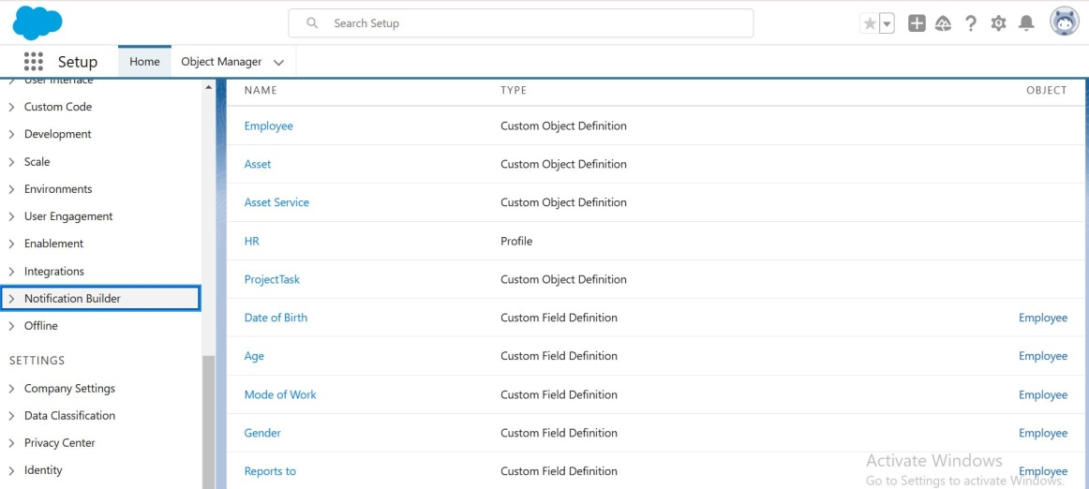

**Tabs:**

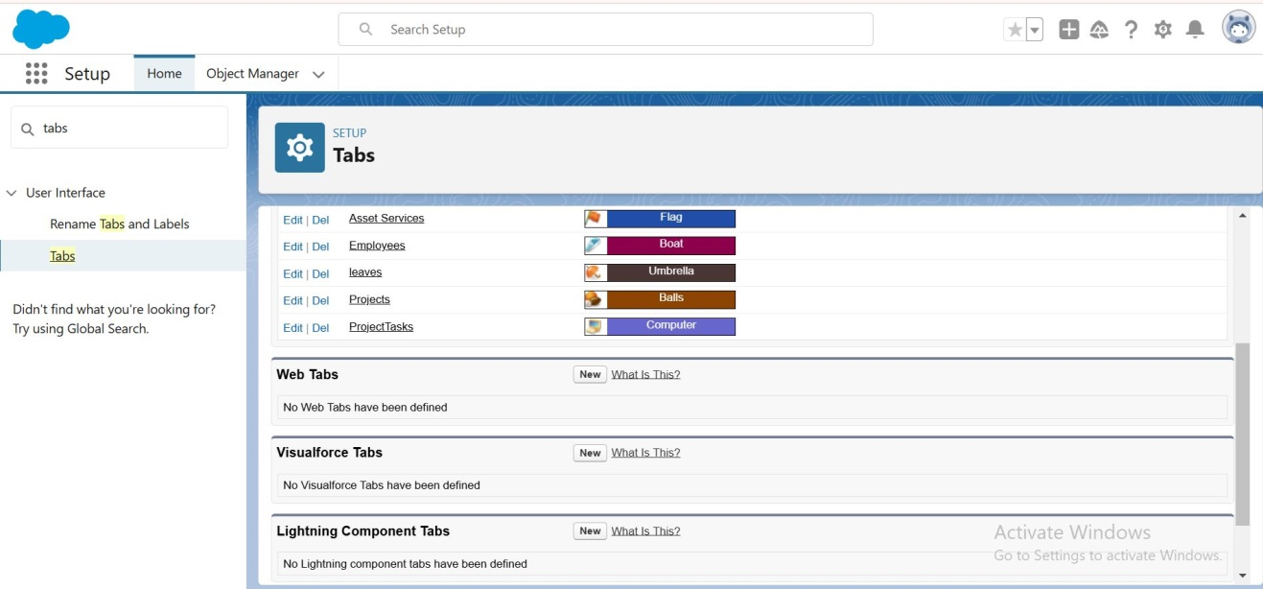

**Importing Data:**

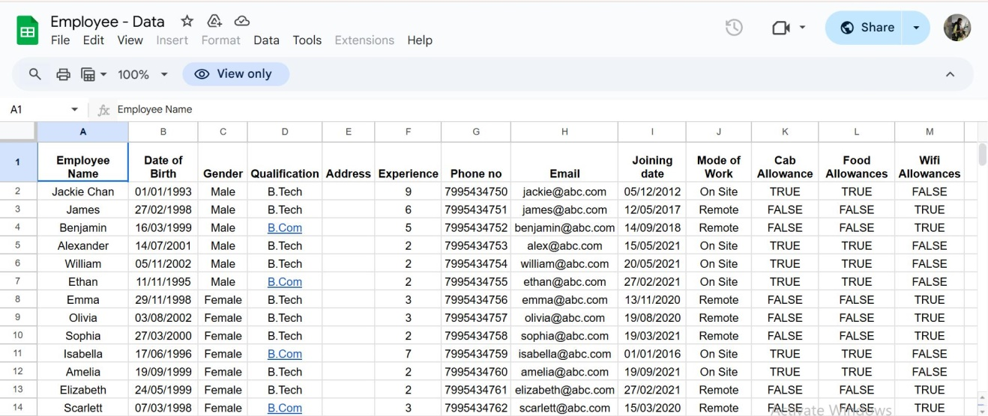

**Users:**

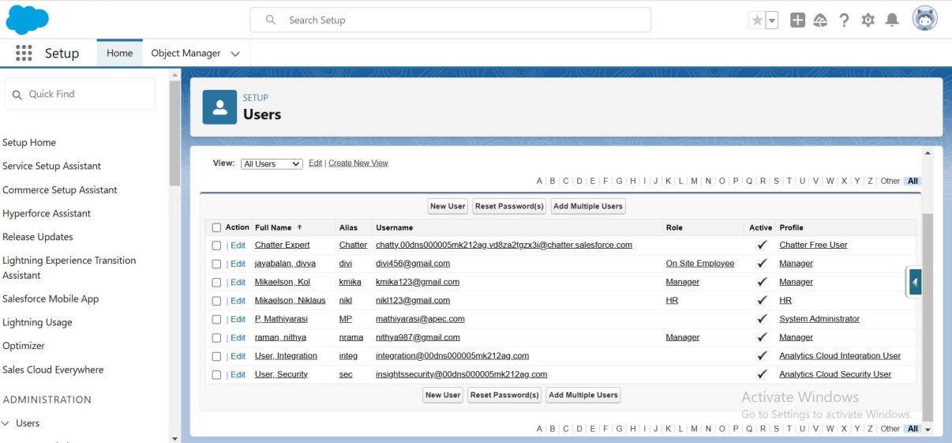

**Chatter Groups:**

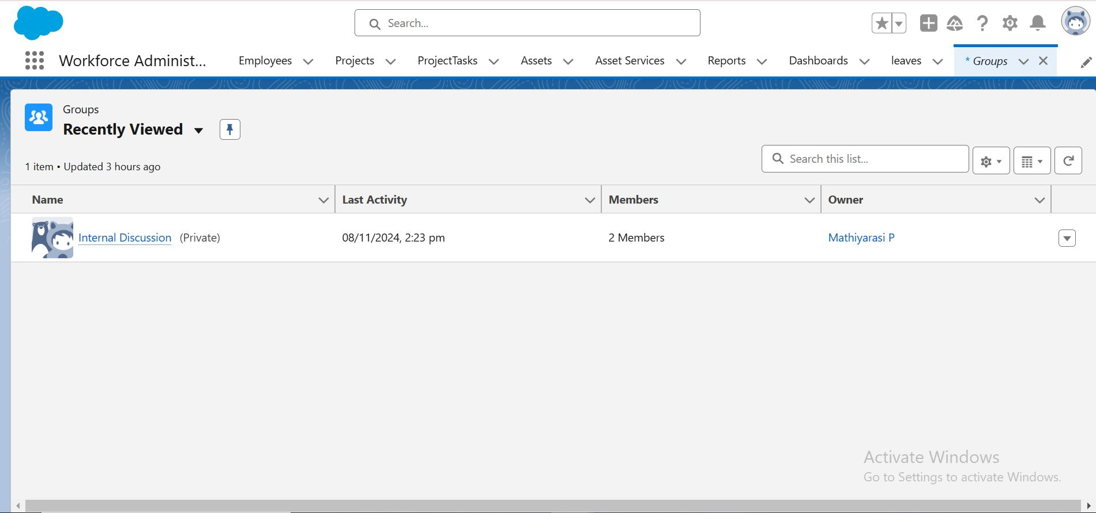

**Reports:**

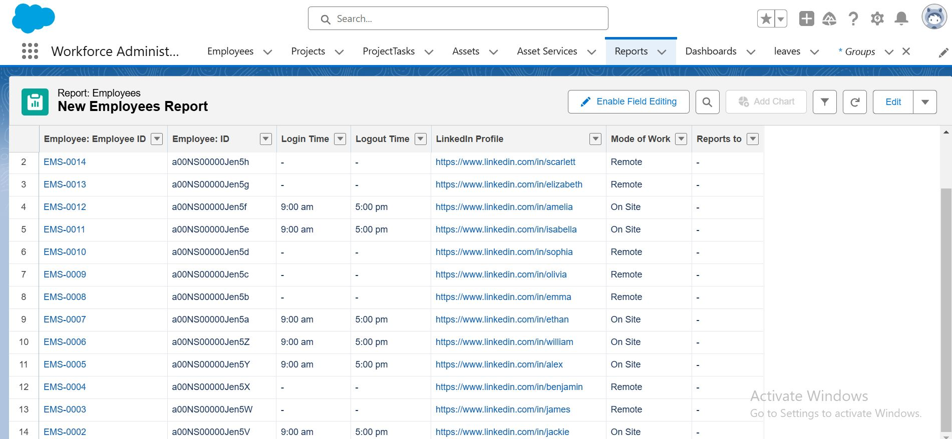

**Testing and Validation:**

To test if a record in Salesforce rejects the creation of an existing employee name, you can create a record-triggered flow that checks for duplicates before saving the new record. Here's a relevant screenshot of the testing process: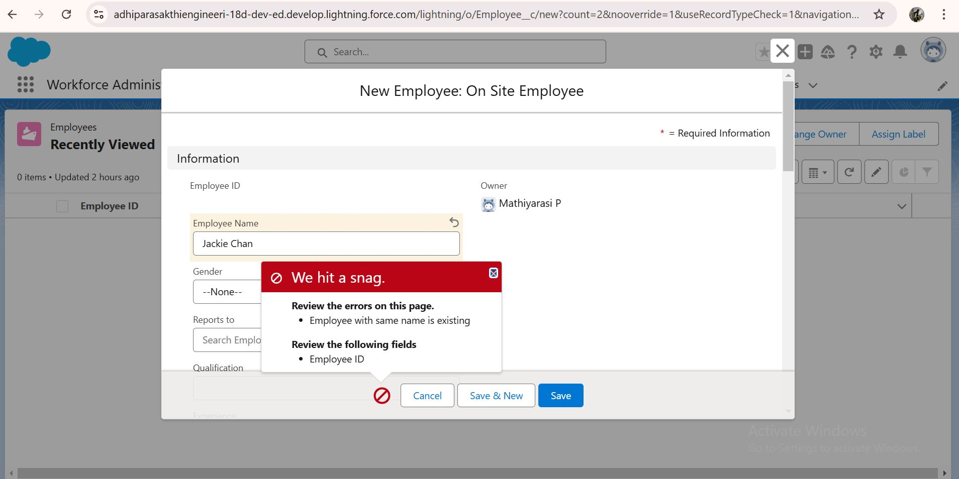

**Apex Triggers:**

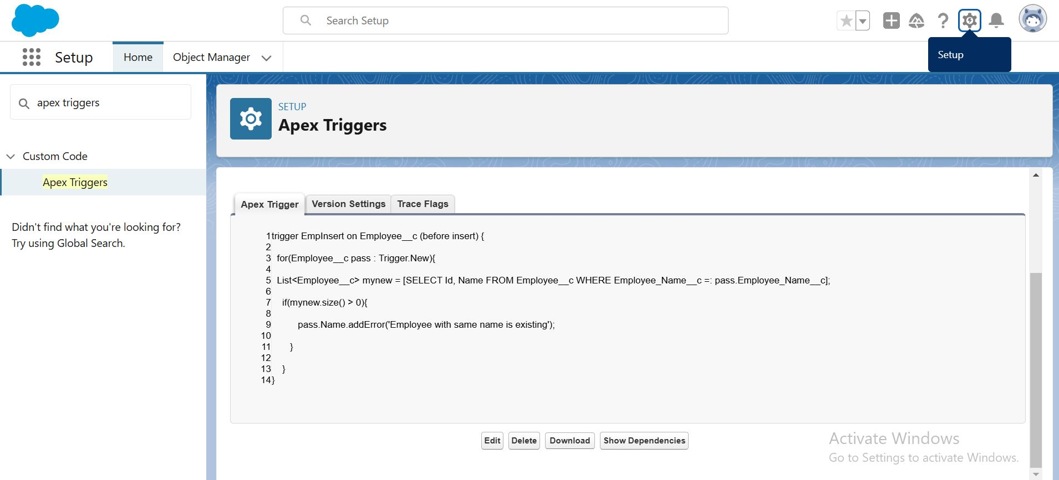

**Key Scenarios Addressed by Salesforce in the Implementation Project:**

**Employee Onboarding and Offboarding:**

* Streamlining the onboarding process by automating the setup of user accounts, permissions, and access to necessary tools and resources.
* Ensuring a smooth offboarding process by revoking access and reassigning assets and tasks.

**Project and Task Management:**

* Tracking and managing projects that employees are assigned to, including deadlines, milestones, and task assignments.
* Providing a collaborative space where team members can discuss project details and share documents.

**Performance Tracking and Management:**

* Monitoring employee performance through integrated performance reviews and feedback mechanisms.
* Identifying top performers and those who may need additional support or training.

**Asset Management:**

* Keeping an accurate record of assets assigned to employees, such as laptops, software licenses, and other equipment.
* Automating the process of asset assignment and returns, ensuring efficient tracking and maintenance.

**Data Security and Compliance:**

* Implementing robust security measures to protect sensitive employee and organizational data.
* Ensuring compliance with data protection regulations and corporate policies.

**Reporting and Analytics:**

* Generating comprehensive reports and dashboards to provide insights into project statuses, employee performance, and resource utilization.
* Customizing reports to meet the specific needs of different departments or stakeholders.

**Bulk Data Import and Management:**

* Importing large volumes of data, such as employee records or project details, into the Salesforce system.
* Maintaining data accuracy and consistency through validation rules and automated processes.

**User Interface Customization:**

* Tailoring the Salesforce interface to fit the specific needs of your organization, ensuring ease of use and accessibility.
* Creating custom objects and fields to capture unique data points relevant to your operations.

**Real-Time Collaboration and Communication:**

* Facilitating real-time collaboration among team members through Chatter or other integrated communication tools.
* Keeping all stakeholders informed and aligned with project progress and updates.

**Conclusion:**

The Workforce Administration Solution leverages the robust capabilities of Salesforce to centralize and streamline various workforce-related processes within an organization. By automating tasks such as employee data management, project tracking, performance monitoring, and asset assignment, this solution enhances efficiency, accuracy, and compliance.

**Output:**

